**Bugs Report**

|  |  |  |  |  |  |
| --- | --- | --- | --- | --- | --- |
| **ID number** | 001 | | **Submit Date** | | 24/01/2025 |
| **Title** | Contact form – “QA Exercise Logo” image is missing. | | | | |
| **Reported by** | Syed Haider | | | | |
| **URL** | QAExerciseNew.html | | | | |
| **Browser** | Chrome 132.x | **Operating System** | | Windows 10 | |
| **Priority** | Medium | **Assigned to** | | (Product Manager/FE dev) | |

**Description**

On the header, the main “QA Exercise” image link is broken and there is no image

**Steps to reproduce**

1. Open the QAExerciseNew.html in a local browser
2. Wait for a couple of seconds

**Actual result**

It displays the broken image icon, and the image source URL doesn’t have an image link.

**Screenshots**  




**Expected result**

QA Exercise logo should be visible.

|  |  |  |  |  |  |
| --- | --- | --- | --- | --- | --- |
| **ID number** | 002 | | **Submit Date** | | 24/01/2025 |
| **Title** | Contact form – Missing contact method | | | | |
| **Reported by** | Syed Haider | | | | |
| **URL** | QAExerciseNew.html | | | | |
| **Browser** | Chrome 132.x | **Operating System** | | Windows 10 | |
| **Priority** | Medium | **Assigned to** | | (Product Manager/FE dev) | |

**Description**

When a user tries to click on the contact method list, it displays an empty option.

**Steps to reproduce**

1. Open the QAExerciseNew.html in a local browser.
2. Click on the “How would you like to be contracted” list under the “Date of Birth” list.
3. Observe the list of options.

**Expected result**

The list should not display the empty option or display the missing one.

**Actual result**

The contact method list is displaying the empty option.

**Screenshots**

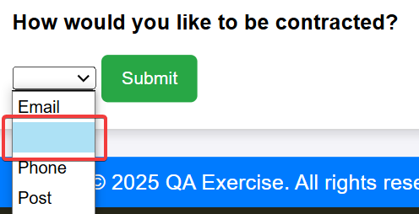

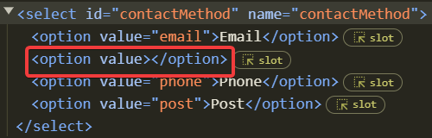

|  |  |  |  |  |  |
| --- | --- | --- | --- | --- | --- |
| **ID number** | 003 | | **Submit Date** | | 24/01/2025 |
| **Title** | Contact form – Misspelt texts | | | | |
| **Reported by** | Syed Haider | | | | |
| **URL** | QAExerciseNew.html | | | | |
| **Browser** | Chrome 132.x | **Operating System** | | Windows 10 | |
| **Priority** | Low | **Assigned to** | | (Product Manager/FE dev) | |

**Description**

On the main form, there are a few spelling mistakes.

**Steps to reproduce**

1. Open the QAExerciseNew.html in a local browser.
2. Click on “Open Contact Form”

**Actual result**

* It displays “**contracted**” instead of “**contacted**”.

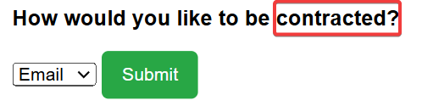

* When selecting “Phone” from the contact method, it displays “**Code Number**” instead of “**Landline Number”.**

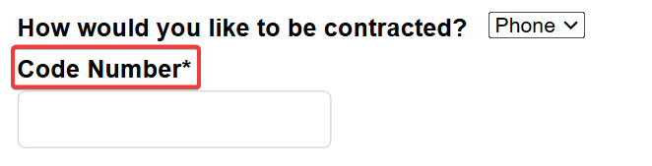

* When selecting “Post” from the contact method, it displays “**Adress Line 1**” instead of “**Address Line 1**” and “**Address Line**” instead of “**Address Line 2**”

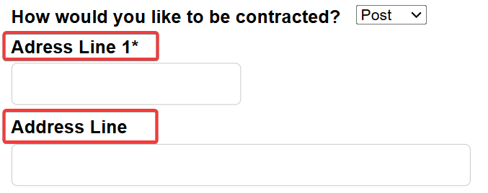

**Expected result**

* The form should display the correct text as follows.
  + “How would you like to be contracted?” change to “How would you like to be contacted?”
  + “Code Number” change to “Landline Number”
  + “Address Line” change to “Address Line 2”

**Note:**

* The “contact method” list control moves to a “weird position” which seems intentional but in terms of UX shouldn’t it remain in its original position when selecting any of its items?

|  |  |  |  |  |  |
| --- | --- | --- | --- | --- | --- |
| **ID number** | 004 | | **Submit Date** | | 24/01/2025 |
| **Title** | Contact form – Compulsory fields indicator | | | | |
| **Reported by** | Syed Haider | | | | |
| **URL** | QAExerciseNew.html | | | | |
| **Browser** | Chrome 132.x | **Operating System** | | Windows 10 | |
| **Priority** | Medium | **Assigned to** | | (Product Manager/FE dev) | |

**Description**

An asterisk (*) should be displayed for all the compulsory form fields.

**Steps to reproduce**

1. Open the QAExerciseNew.html in a local browser.
2. Click on “Open Contact Form”.

**Actual result**

* “Mobile Number” should have an (*) after it as there is an error message generated when the user does not enter the numbers

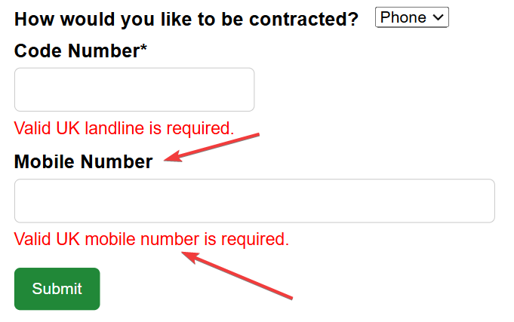

* “Postcode” should have an (*) after it as there is an error message generated when the user does not enter it and click “Submit”.

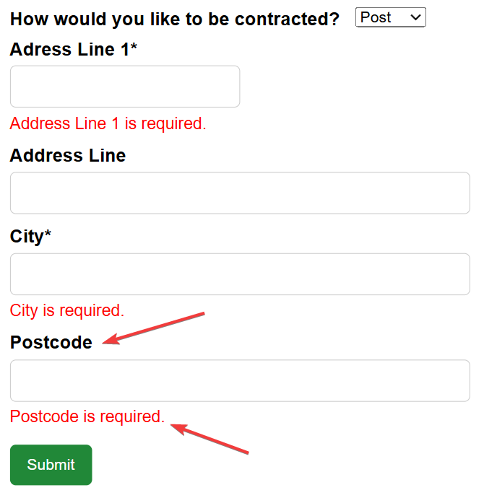

**Expected result**

All the compulsory fields should display the (*) for the users to be aware of entering the data before submitting the form.

**Note:**

* Shouldn’t we have a valid postcode regex check in place?